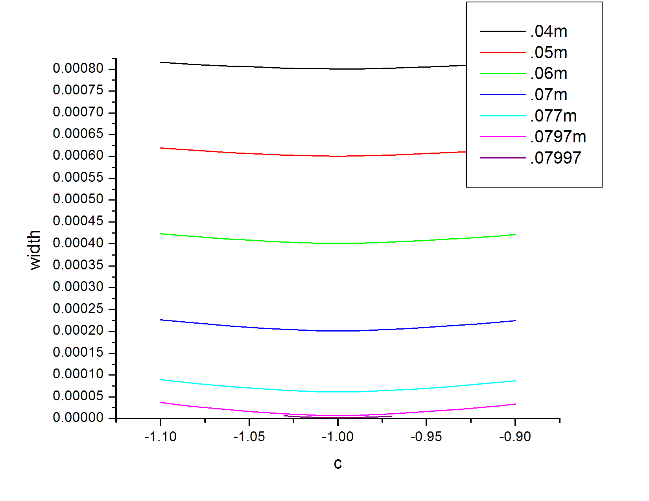

dw

This graph shows the different tuning graphs. Each line has a different value for dw (the width of the filter). It shows that the greater the ratio between the total path and the length of the filter the smaller the pulse width. I went this route because I noticed that the velocity spread was a much greater factor in pulse width than angle for the values I was using. So I looked at my equation for pulse width based on velocity spread. I used d_tot=.08m, a=.01, c=-1 and varied d_w.

$Δx=2d_{tot}a+2acd_{w}+acd_{w}\left(1+c\right)\left(\frac{1}{1+a\left(1+c\right)}+\frac{1}{1-a\left(1+c\right)}\right)$

The equation simplifies down to

$Δx=2{a(d}_{tot}-d_{w})$

d_w cannot be bigger than d_tot so the closer d_w is to d_tot the better the pulse.

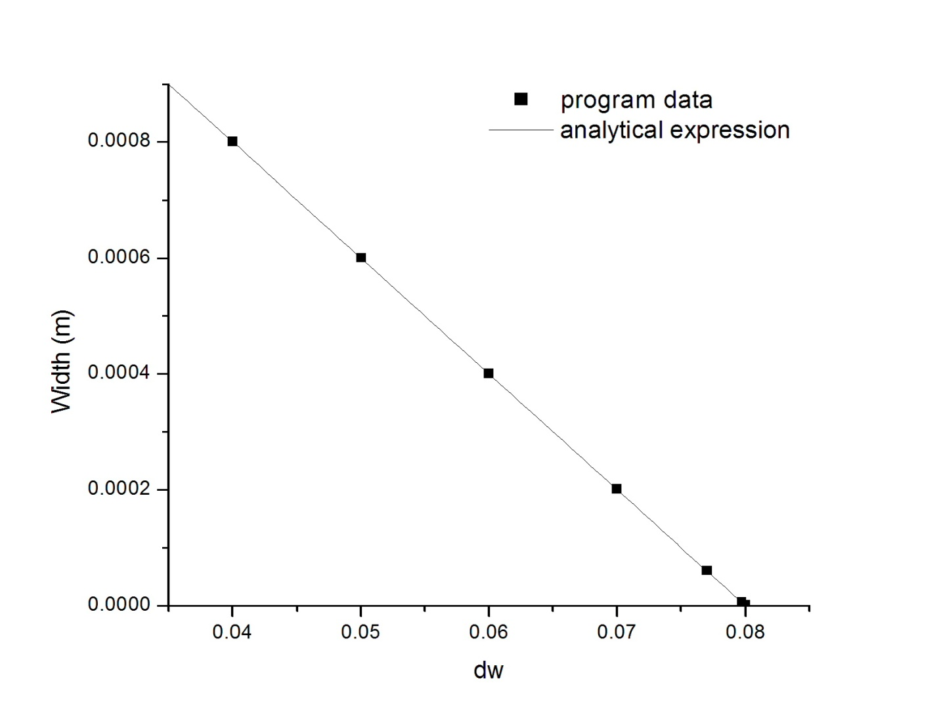

This equation was supported by the above data from the program. The last data point gives a width of 2.04e-6 m. but the analytic expression says that it should be 6.34e-7 m. This suggests that the angle is causing more breakdown than the velocity spread by this point.

Another factor I considered was the overall length of the system. So far I have been using d_tot=0.08m. Here I tried a few different total lengths. Here is the result

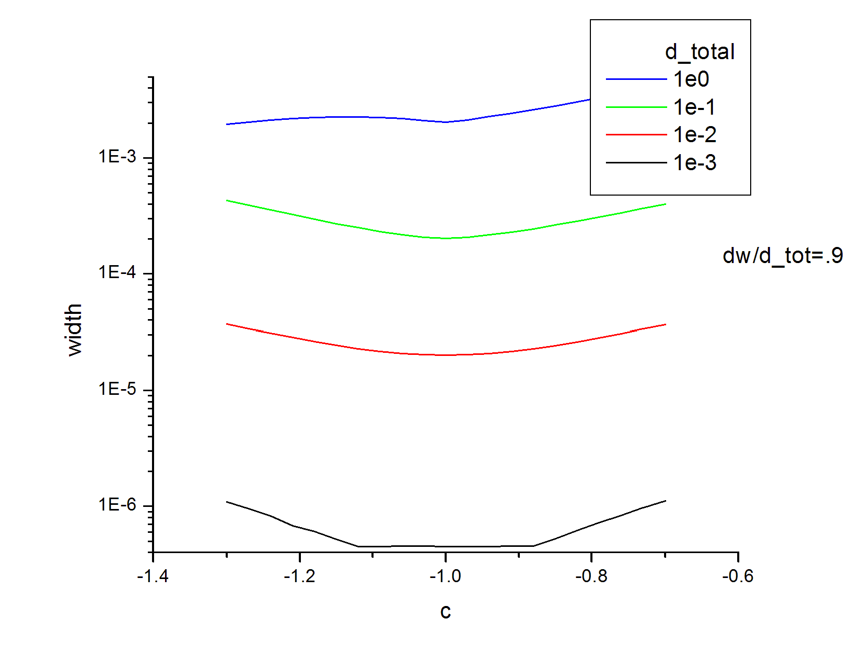

This is the data for the minimums of the above graphs

|  |  |
| --- | --- |
| D_tot | Width |
| 1E-3 | 4.49888E-7 |
| 0.01 | 2.00531E-5 |
| 0.1 | 2.01796E-4 |
| 1 | 0.00204 |

These results seem to be quite linear based on the graph below until you get to 1e-3. Then the effect is greater giving an even better focus. This however maybe a difficult system to make physically.

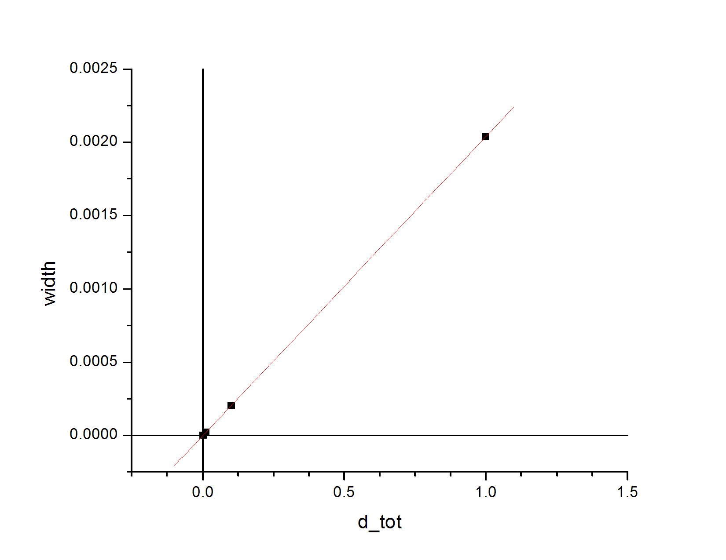

NOTE: all tests shown use a velocity spread of ±1% and ±.005 radians.

c=4Ed/(Bv_0)